**Ansible Installation**

apt update

apt install python3-pip

pip install boto boto3

sudo apt update

sudo apt install software-properties-common

sudo add-apt-repository --yes --update ppa:ansible/ansible

sudo apt install ansible

Above link is aws plugins:

https://docs.ansible.com/ansible/latest/collections/amazon/aws/index.html#plugins-in-amazon-aws

1. Create new iam user

2. And give permission to ec2 full access

3. Click the user and create access key and secret key

nano /etc/ansible/hosts

##[webserver] - below webserver to paste ipv4 address

Ipv4 address

Cd /etc/ansible/

Nano ec2_create.yaml

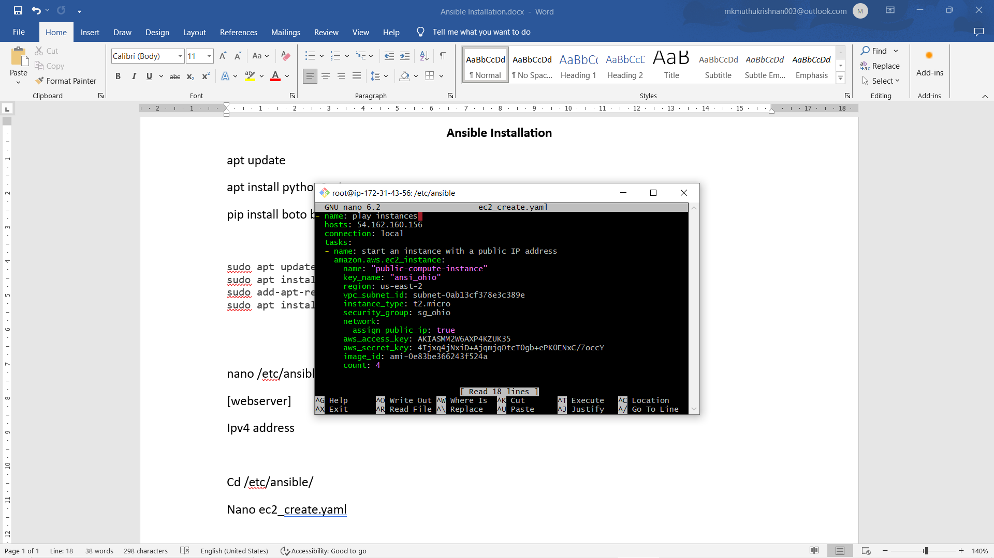

Checking the code: ansible-playbook -C ec2_create.yaml

Execute the code: ansible-playbook ec2_create.yaml

**Sign in to the AWS Management Console:** Go to https://aws.amazon.com/ and sign in to the AWS Management Console using your AWS account credentials.

**Access IAM (Identity and Access Management):** IAM is the service in AWS that enables you to manage access to AWS services and resources securely. In the AWS Management Console, search for "IAM" in the services search bar, or navigate directly to the IAM dashboard under "Security, Identity & Compliance".

**Navigate to Users:** In the IAM dashboard, select "Users" from the left-hand navigation pane. This will display a list of IAM users in your account.

**Select Your IAM User:** Find the IAM user associated with the access keys you want to access. Click on the username to view the details of that user.

**Access Key Section:** In the "Security credentials" tab of the IAM user details page, you'll find the "Access keys" section.

**View Access Key:** If there are existing access keys associated with the user, you'll see them listed here. You can view the access key ID, and you can also click on "Show" next to the access key to reveal the corresponding secret access key.

**Create Access Key (if necessary):** If you don't have any existing access keys or need to generate new ones, you can click on the "Create access key" button. AWS will generate a new access key pair consisting of an access key ID and a secret access key. Be sure to download or copy the secret access key immediately as it won't be visible again.

**Using two or more server:** 